Functional Specification

|  |  |  |
| --- | --- | --- |
| Retrieve messages from server | Description | Priority |
| Local Registration | Hash db w/ username + password + device id | 1 |
| Local Login | Decrypt database with username + password + device id | 1 |
| Post message to server | Send message to central server | 1 |
| Retrieve messages from server | Retrieve messages from central server and save to local db | 1 |
| Display messages in thread | Retrieve messages in chronological order | 1 |
| Encryption Layer | Asymmetric encryption on all traffic | 1 |
| Adding contacts | Add contacts by username or phone number | 2 |
| Viewing contacts | View existing contacts, click for separate individual contact view | 2 |
| View individual contacts | View separate page with user profile | 2 |
| Add message to profile | Add message to profile | 3 |

Overview

Key is an end-to-end encrypted mobile app that allows users to send messages to individuals or groups.

Scenarios/Use Cases

Scenario 1: Mike

Mike is an early adopter of privacy technology. He despises Facebook, Instagram, and other social media platforms that require public information sharing and use his data to their advantage (to make money). Mike sometimes sits in front of a laptop in dark room and engages in hackathons. Mike is a Key user for the sole reason that Key is an encrypted network. He sends encrypted messages back and forth to his Star Wars loving friends. His friends says, “Hey Mike, want to go to the movies later and watch the new Cybertron movie, it’s gonna be wild! After we can look at girls!!!.” Mike loves that he owns his information, not Zuck. He may also occasionally wear a t-shirt that reads “Thank you Snowden.”

Scenario 2: John

John graduated from college and misses chillin with his friends who are now bankers, consultants, and in the Peace Corps and working globally. He’s now on a beach in Florida programming for a few startups and drinks mimosas in the morning. He uses Key to share his experience with friends who are living across the world. He drops his location at the local surf spot and shares front and back camera shots of the waves before he crushes a set. One friend, now a glazed eyes investment banker, responds with a selfie of him at the strip club, it’s 7am and he still hasn’t left since he got there the night before, it reads, “models and bottles bros.” John laughs, feeling sorry for this friend, as the previous Friday at 10pm he received a pic from the same bro of two computer monitors and no visible signs of life forms. John responds, “Quit that job yet bro?” and inserts a pic of a cresting wave while simultaneously dropping his Dayton beach location.

Scenario 3: Rachael

Rachael is finishing her senior year at Darien High and was recently accept to Duke University. She has to manage her friends and enemies to properly maintain her social status at Darien. Rachael uses Key to ensure her messages are not put on display the morning after she releases them. Because you know, Rachel is best friends with Sarah and Rachael hates Allie. But Sarah actually likes Allie. To avoid past problems, she talks badly to Sarah about Allie over Key because her messages evaporate and she can have fun and insert dagger-like emoji graphics going into Allie. Additionally, Rachael is way to cool for buzzfeed content suffocating her feed and random *Jersey (not Darien)* bros requesting her friendship, so she chooses to use Key. Lastly, Rachael showcases how rich she is. For example, Sarah taps on Rachael’s most recent message and they see her location in St. Tropez before the combined beach landscape/selfie photo. Sarah plots to kill Rachael. Also, the word on the street is her best friend could only get into a state school, so she was immediately downgraded to a loser.

Scenario 4: JJ

JJ is a complete bro. Always traveling and broing out. He wants to communicate with his bros while in Vegas and be able to organize plans and share his closest friends. He likes Key because he can monitor his bros if they drift drunkenly into a different casino. He enjoys sharing information and pics with the bros in Key which automatically preserves photos, videos, and text from his group messages on his profile so that it’s only visible to the closest Vegas bro clan. In one instance while some bros are at lunch, he sends them a pic holding a hand full of cash from successfully betting on horses. Good memories and experiences. Upon entry to the group, he’s glad he can tell who is speaking because on one trip to Vegas, his cool brother Rob invited his ballin friend Brendan and JJ didn’t have his cell phone number. However, Brendan’s photo is strategically next to his message. “Who the heck!?!. Ohh, it’s Brendan…thank gosh for this functionality,” JJ says.

Scenario 5: Kate

Kate is the oldest of 4 siblings. She likes to share information with her younger brothers. She realizes when using Key privacy vulnerabilities still exit. Similar to Snapchat, her brothers have taken a screenshot and shared her content when she admits their friend is cute. Kate likes that she doesn't have to worry about a privacy setting changing and her parents suddenly being able to see all of her content, but she realizes that she still has to be careful with what she shares with other users.

Scenario 6: Emily

Emily’s boyfriend is a Navy SEAL and she had always used Snapchat until recently when her pictures were released to the world along with Jennifer Lawrence’s. She uses Key because it is a private medium. She likes to share pictures of her naked body. Her bf still screenshots and she whines about it.

Non Goals for v0.1

* Create groups
* Any form of substantial profile (picture)
* Send:
  + Photos
  + Videos
  + Emoji’s
* Time expiry function

Flowchart

Login

Photo, Video Screen

//swipe left

Friend map

//swipe left

Your groups and individual friends

//swipe left

Enter into a conversation

//swipe right from photo, video screen

Contact list – ability to add friends

Storyboard - Screen by Screen Specs

Page 1 – Login Form

The login page serves as the home page of Key. Here, the user signs up for the app. Members who have already signed up for Key will log on and eventually will not have to revisit the login screen (automatic log in).

The Key graphic will be displayed at the top center of the homepage screen. Following will be “Key”, the app name. Next, we allow the user to sign up using their phone number or create a unique user login. Clicking login will bring the user to the second page of the app.

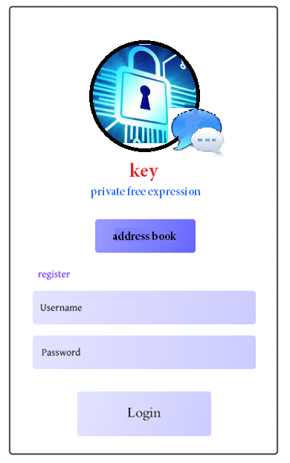The Log in screen will look something like this (design not nearly complete):

Page 2 – Photo/Video

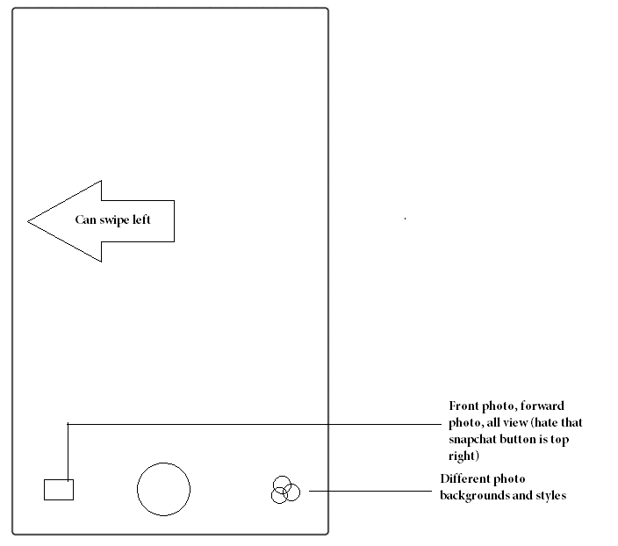

Page 3 – Map of friends

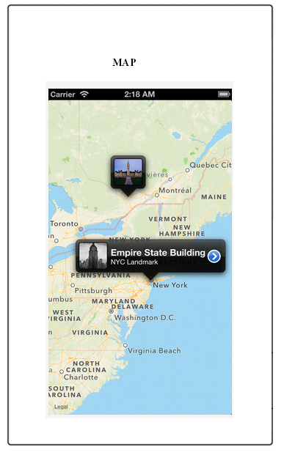

Page 4 – Customized group and individual relationships

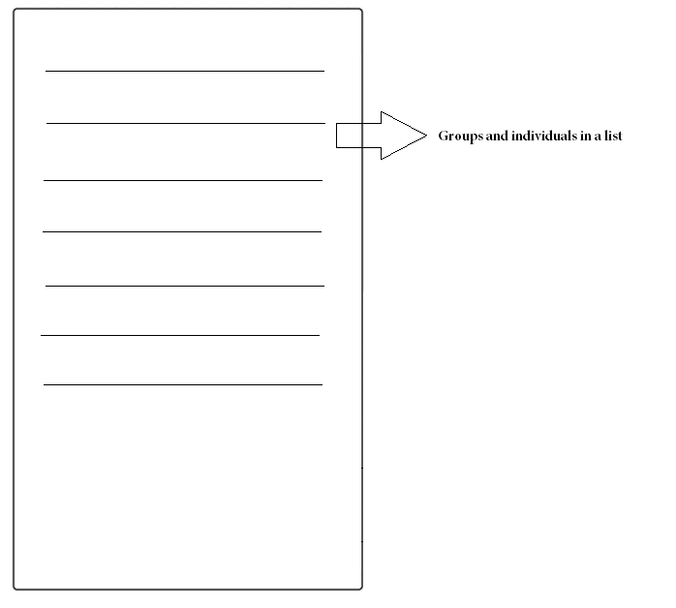

Page 5 – Swiping right on the photo/video screen will bring a user to the contact/add friend page

